**Electric Skateboard - esk8**

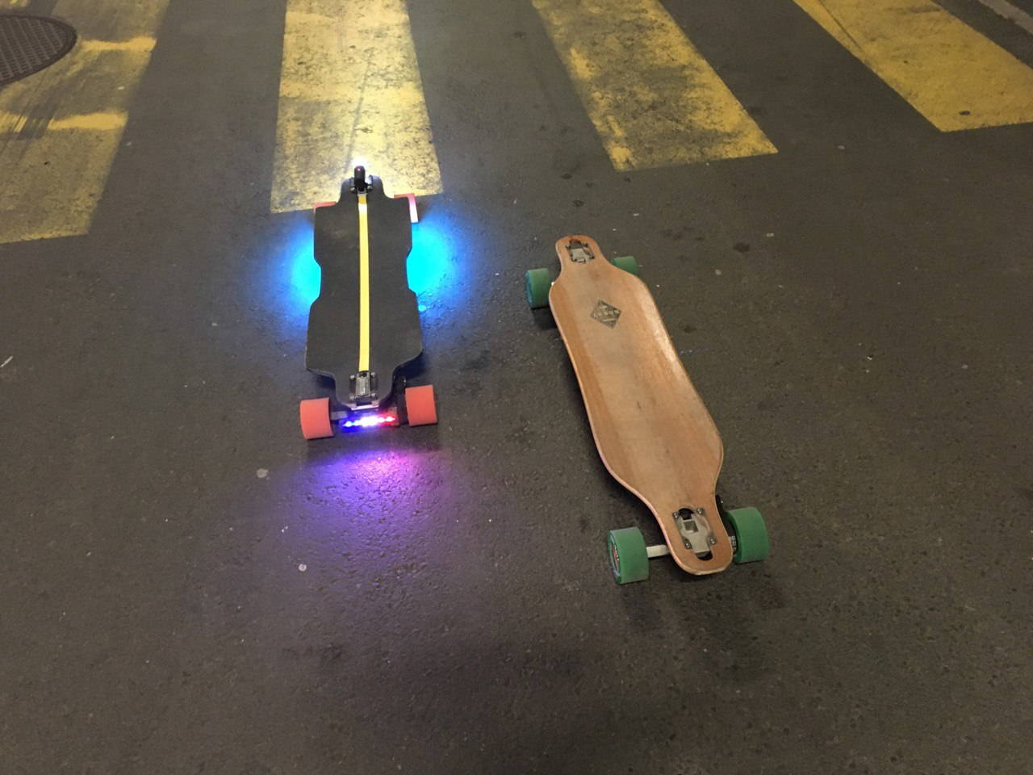

This report presents my project of an electric skateboard that I made at Robopoly. My skateboard can reach 40kph and its range is about 30kms. It goes without saying that wearing a helmet is a must!

The idea behind electric skateboard is to have a high-capacity battery, providing energy to an electronic speed controller in order to drive the motor according to an input provided by a RC remote.

There are already several electric skateboard that can directly be bought from companies, but I wanted to make my own to have a better understanding of how to build one as well as to have the possibility to customize it. However, making a custom electric skateboard is often more expensive that just buying one!

Table of Contents

Mechanics 3

Regular longboard: deck, trucks, wheels and bearings 3

Electronics 5

Motor and transmission 5

Speed controller: VESC 6

Remote 6

Battery 7

Custom 8

App and LEDs 8

Price 10

Useful websites 11

Forums 11

Mechanics

Regular longboard: deck, trucks, wheels and bearings

For an electric skateboard it is important to have good and robust mechanical parts, as they have a direct link to the safety when riding at high speed.

For this project, I bought an old longboard found on the internet. It’s a “Sportster element” of the American company Bustin. I particularly liked its shape that’s why I chose it.

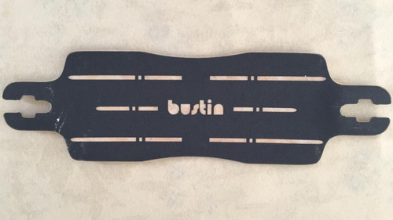

But any regular longboard should do the trick. One just wants to avoid very cheap longboard (like the one found in general sport shop like Decathlon or similar) as they are not suited to handle speed. They are a lot of example of cheap skateboards, that broke during riding (as well as the rider’s bones)!

One thing to have in mind, is the length of the longboard. The longer the deck, the more stable the ride and the bigger the batteries you would be able to fit under it. But the bigger the batteries, the more weight you would have to carry.

Here is a list of famous decks for esk8:

* Bustin: quasi all the decks
* Axis
* Loaded Tesseract (or Truncated Tesseract)
* Loaded Vanguard
* Madrid 40”

It’s also possible to build its own deck with some plywood but this requires having a press or vacuum bag. This is recommended when you know perfectly what you want, as you can choose the thickness, the type of wood you want to use…

For the trucks, I chose to use the Caliber II 50° (left image) as they are quite famous for this longboarding application and I just love them. Other famous trucks are the Paris V1 (or V2, right image).

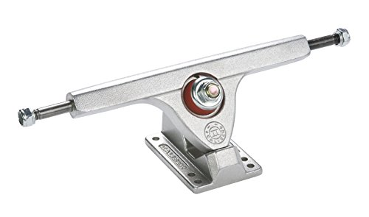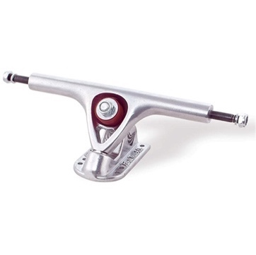

For the wheels, there are many choices, but you need to find wheels with a core that allows to mount a driver on it (= a core with holes in it, to fit screws). They are 2 types of cores, respectively the Kegel core (left image) and the Flywheel core (right image). Those cores are widely used in clones wheels.

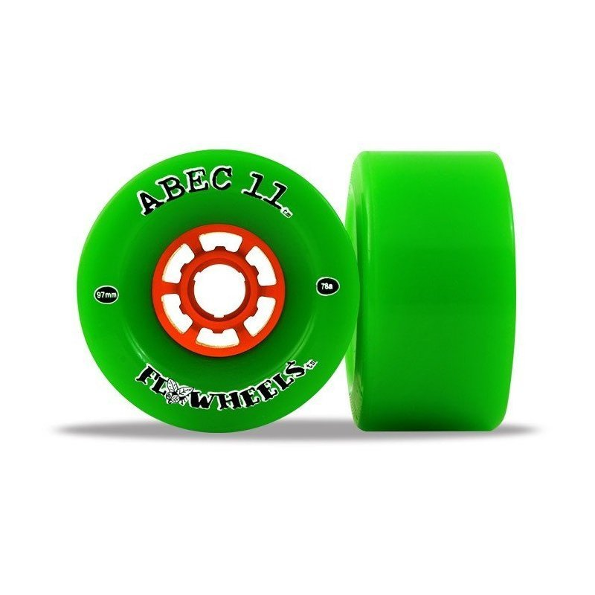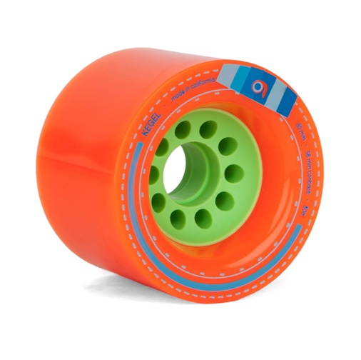

When selecting wheels, you have to choose what hardness you want to have. The hardness is given by a number and a unit. The most used unit is the durometer A scale. A wheel with this scale would be tagged as “XXa” where XX is the hardness. The higher the XX, the harder the wheel.

The diameter of the wheels plays an important role as it is directly linked to the maximum speed the skate can reach. Having a high diameter (around 90-100mm) allows for high speed but a small diameter allows to have good torque (useful when rising uphill). You can use the following calculator to select what you want: <https://calc.esk8.news/#/0> by changing parameters and reading the calculated results.

The famous wheels for esk8 are the Orangatang Kegel, Orangatang Caguama or Flywheels (official or clone).

Having chosen the wheels, one should think about the bearings to use with the wheels. My preference goes for the Bones bearing Reds. They are quite expensive but very smooth and it is very pleasant to ride with them. But basically, any bearings found in skate shop should work.

Recap of my choices:

|  |  |
| --- | --- |
| Deck | Bustin Sportster |
| Trucks | Caliber II 50° |
| Bearings | Bones Reds |
| Wheels | Orangatang Kegel 80A (80mm) |

Electronics

Motor and transmission

There exist many different motor configurations for electric skateboards. One could use a single motor on the hind truck (single, propulsion) or two motors on the hind truck (dual rear). It even exists a diagonal motor repartition (dual diag): one motor at the front left wheel and the other at the hind right wheel (or inverse). Having two motors offer a better riding experience, a better braking but comes at the cost of increasing costs and weight of the board. In this project, I am using a single motor.

Electric skateboards are typically driven with BLDC motors as they offer a high power-to-weight ratio and high speed. The drawback is the need of an Electronic Speed Controller (ESC for short) to actually drive the motor.

The dimensions of a BLDC motor are given as XXYY where XX and YY denotes, respectively, the diameter of the motor (in mm) and its length. Typical motors dimensions are 5065, 6355, 6374.   
A motor is also characterized by its KV number (a low Kv indicates lower speed but more torque, to be adjusted with wheel size and transmission ratio). Typical KV values for esk8 range from 130 to 250Kv. Again, you may want to use the calculator whose link is provided above.

The motors can be sensored or sensorless. The presence of sensors (often Hall sensors) inside the motor allows the controller to know the rotor’s position and this is useful for starting; it allows a very smooth start. A sensored motor can be recognized with the presence of an “S” at the end of its dimension code (becoming XXYY-S). I am using a 6374S from Alien Power System.

To transmit the motor torque to the wheel, one needs a motor mount, a motor pulley and a wheel pulley as well as a drive belt. Pulleys of all sizes exist, and one should think of the gear ratio. Regarding the motor mounts, many exist; just take care of the compatibility between the mount, the truck and the motor. It can be useful to purchase the motor as well as the motor’s mount on the same website. At the end of this report, you will find some useful websites to purchase esk8 parts.

For the wheel drivers, it is possible to 3D-print them but be sure to have a sufficient infill. 3D-printing them allow to play with the number of teeth and to test different gear ratios.

*Note that I am not using brakes in this project as motor braking is implemented in controllers!*

Speed controller: VESC

Driving a BLDC motor require an electronic speed controller that replaces the commutator assembly of the brushed DC motor. This controller continually switches the phase to the windings to keep the motor turning.

I am using a VESC (Vedder Electronic Speed Controller): an open-source project of B. Vedder (see <https://vesc-project.com/>). This controller is awesome as it comes with an also open-source software to setup the controller, allowing the user to tune many parameters such as drive type (FOC vs BLDC), throttle curve, timeout brakes, braking power… This controller also has many ports allowing to communicate over UART, to link Hall sensors to it... There are many tutorials on the internet and wizards in the software to help the users to get their controllers setup.

This is a must-have: one of the best controllers. There are different hardware versions of this controller, according to the voltage and current rating.

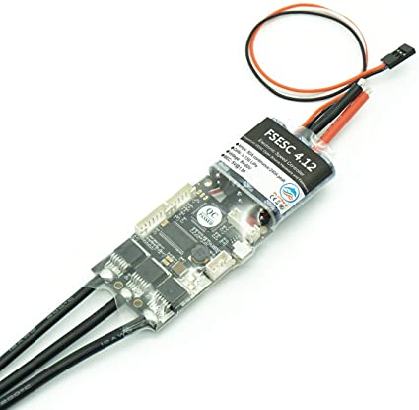

The version 4.12 of the VESC, the one that I use.

Remote

For the remote control of the skate, I am using standard radio receiver are they are very basic and robust. When using Bluetooth remote, short disconnection can happen, and that’s the main reason why I chose RC. My remote is the well-known GT2B from Hobbyking.

Those kind of RC remotes are easily modifiable, and I plan to 3D-print a smaller version of it by removing the 2 channels that I am not using.

Battery

The battery is a crucial part as it will directly impact your speed and your range.

The most used batteries for this kind of application are LiPo batteries due to their high specific energy. They are made of cells (denoted by the letter S), each having a nominal voltage of 3.7V.

By chaining cells in series, we add the voltage, so 4 cells make a 3.7*4 = 14.8V battery. By chaining the cells in parallel, we add the capacity and thus the range of the skateboard. As for the motors, the batteries have a naming code. A “10S4P” battery stands 40 cells: 10 cells in series and 4 in parallel.

One can directly buy battery from retailers or build on. I went for the first option and I bought a 10S4P battery.

Enclosure

All the electronic is fitted inside an enclosure that is screwed below the deck. They are many different shapes, sizes and plastics used. I am using a regular ABS enclosure (left image below) for the battery as well as a custom 3D-printed box to store the controller and the Arduino.

Custom

App and LEDs

I wanted to have a more custom electric skateboard, so I added some LEDs below it to have some kind of a glow effect when riding.

In order to do so, I purchased LEDs strips at Robopoly. The strips are protected with a 3D-printed structure as well as a layer of PMMA. The LEDs holders are then directly screwed in the deck.

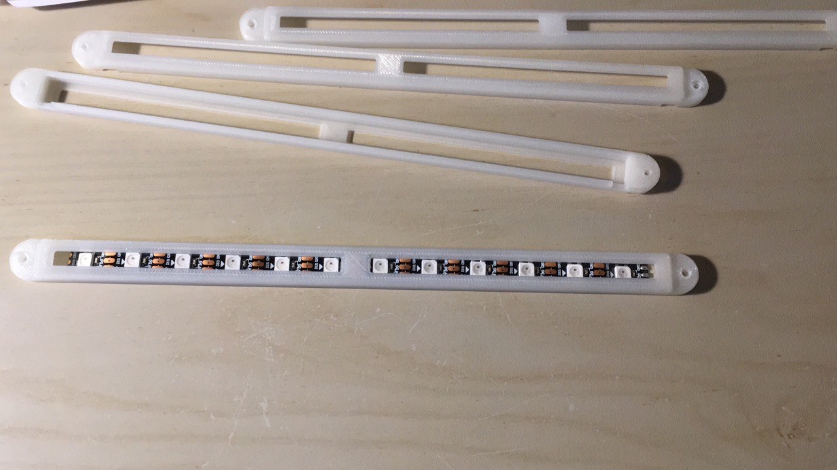

An arduino nano drives the LEDs strips according to some commands that are sent from a custom app over Bluetooth. The app was developed in Swift (for iOS) using very basic tutorial on YouTube. The Bluetooth module that I chose is the HM10 because it’s a BLE (Bluetooth low energy, compatible with iPhones) device and it is cheap.

The HM-10 BLE module.

A screenshot of my application is presented below. The application provides information about the current speed and some features of the controller. A segment selector allows to choose the color of the LEDs strips (between blue, red, yellow, purple and white).

At the back of the skate, I have a programmable rear light to mimic braking intensity like for cars. This light can also be used to display a flag. The blinkers are implemented and can be used when turning although it’s more convenient to use the hand ☺

Price

The following table presents the prices of the parts I purchased. I didn’t add the cost of 3D printing.

|  |  |
| --- | --- |
| Bustin Deck | 100 CHF |
| Caliber Trucks | 70 CHF |
| Orangatang Wheels | 60 CHF |
| Bones Reds | 25 CHF |
| Motor APS 6374S | 80 CHF |
| Motor mount and pulley | 70 CHF |
| VESC controller | 50 CHF |
| Battery | 180 CHF |
| Arduino Nano + LEDS, Robopoly | < 15 CHF |
| Remote | 30 CHF |
| **TOTAL** | **680** **CHF** |

Building a custom electric skateboard is thus quite expensive but the price can be reduced by buying already used items (what I did for some parts). On the forums (see next section), there is often a “parts market” section.

Useful websites

Forums

A lot of information and help can be found on forums. It is then recommended to read a lot of posts to get a general overview of electric skateboards.

* Esk8 Calculator: <https://calc.esk8.news/#/0>
* VESC project: <https://vesc-project.com/>
* French-speaking forum: <https://www.e-sk8.fr/>
* World forum: <https://forum.esk8.news/>

Stores

For the stores, I highly recommend electricboardsolutions (<https://electricboardsolutions.com/>) as it propose fair prices and has good parts.

* <https://www.skatepro.ch/fr/>
* <https://alienpowersystem.com/>
* <https://electricboardsolutions.com/>
* <https://hobbyking.com/>
* <https://flipsky.net/>